**HR Analytics Test Report**

This SQL project involved the creation of an HR Database in PostgreSQL to facilitate a comprehensive assessment of Power BI report - HR Analytics Dashboard.

This report serves as a validation of the Dashboard created for HR Analysis for an organization. The validation is done in SQL and addresses **functional and data validation.**

**Functional validation** was conducted to evaluate feature functionality, confirm filter accuracy, and ensure compliance. **Data validation** was performed by cross-referencing Power BI values with SQL queries to guarantee data accuracy. The project's findings were consolidated into a comprehensive test document, which included screenshots of queries, and the resulting outcome. This documentation serves as a valuable resource for informed decision-making and data-driven insights.

**Tools:**

Tableau, Microsoft Power BI and PostgreSQL

**Requirements:**

**KPI’s;**

The HR Department is responsible for monitoring and managing various aspects of employee data to ensure the organization maintains a healthy workforce. However, there is lack of a clear performance indicator to track and analyse key HR metrics. Therefore, there is need to design and implement a set of KPI’s to address the following points:

1. **Employee Count:** The HR department lacks visibility into the total number of employees, making it a challenge to assess workforce size and plan for future growth or downsizing effectively.
2. **Attrition Count:** The Organization lacks a standardized method to track employee attrition, resulting in incomplete and unreliable data on the number of employees who have left the organization.
3. **Attrition Rate:** Without a clear measure of attrition rate, the organization cannot assess the overall turnover level or compare it with industry benchmarks, hindering the ability to gauge employee satisfaction and engagement.
4. **Active Employees:** The Organization lacks a mechanism to differentiate between active and inactive employees, leading to difficulties in accurately assessing the current workforce’s productivity and capacity.
5. **Average Age:** The HR department lacks visibility into the average age of employees, making it difficult to evaluate workforce demographics, succession planning, and the organization’s ability to attract and retain younger talent.

**CHARTS/VISUALIZATIONS;**

1. **Attrition by Gender:** The HR department faces challenges in understanding patterns based on gender, making it difficult to identify ant gender related disparities and implement targeted retention strategies.
2. **Department-wise attrition:** The HR department lacks visualizations to showcase attrition rates across different departments. This hinders their ability to identify departments with high attrition rates and address any underlying issues or concerns effectively.
3. **Number of Employees by Age group:** The HR department requires visual representations to analyze the distribution of employees across various age groups. This helps in assessing workforce demographics, identifying any age-related gaps or imbalances, and implementing targeted HR policies or programs.
4. **Job satisfaction ratings:** There is a lack of visualizations by the HR department to represent job satisfaction ratings, hindering their ability to measure employee engagement and overall job satisfaction levels effectively.
5. **Education field attrition:** There is a requirement by the HR department to have visual representation to analyzed attrition rates by education fields. This helps identify specific educational backgrounds that may be associated with higher attrition, enabling the organization to tailor retention strategies accordingly.
6. **Attrition rate by gender for different age groups:** The HR department lacks visualisations that display attrition rates based on gender and different age groups. This makes it challenging to address any gender and age-related attrition trends, preventing the organisation from implementing targeted retention strategies for specific employee segments.

**SQL QUERIES AND OUTPUTS;**

The SQL queries that speak to the requirements are as below. There is also a screenshot of the respective visuals from Tableau/PowerBi. The screenshot of the dashboard is as below, where reference will be made.

Creating the Table

**Create Table**

**CREATE** table hrdata

(

emp_no int8 PRIMARY KEY,

gender varchar(50) NOT NULL,

marital_status varchar(50),

age_band varchar(50),

age int8,

department varchar(50),

education varchar(50),

education_field varchar(50),

job_role varchar(50),

business_travel varchar(50),

employee_count int8,

attrition varchar(50),

attrition_label varchar(50),

job_satisfaction int8,

active_employee int8

);

Import Data in Table Using Query

COPY hrdata FROM 'E:\PROJECTS\HR ANALYSIS\PostgreSQL report' DELIMITER ',' CSV HEADER;



-- Check if all the data has been imported

**select * from hrdata;**

1. TESTING THE KPI's IN THE DASHBOARD
   1. TOTAL EMPLOYEE COUNT

**select sum(employee_count) as Employee_Count from hrdata;**

**-- or**

**select count(emp_no) from hrdata;**

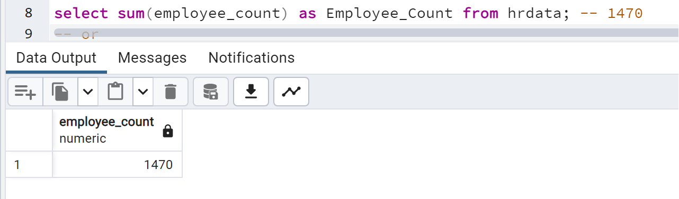

* ASSOCIATES DEGREE

**select sum(employee_count) as Employee_Count from hrdata where education='Associates Degree';**

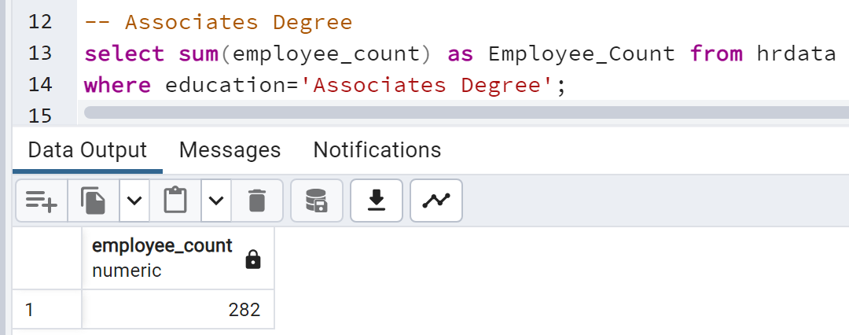

* BACHELOR'S DEGREE

**select sum(employee_count) as Employee_Count from hrdata where education='Bachelor''s Degree';**

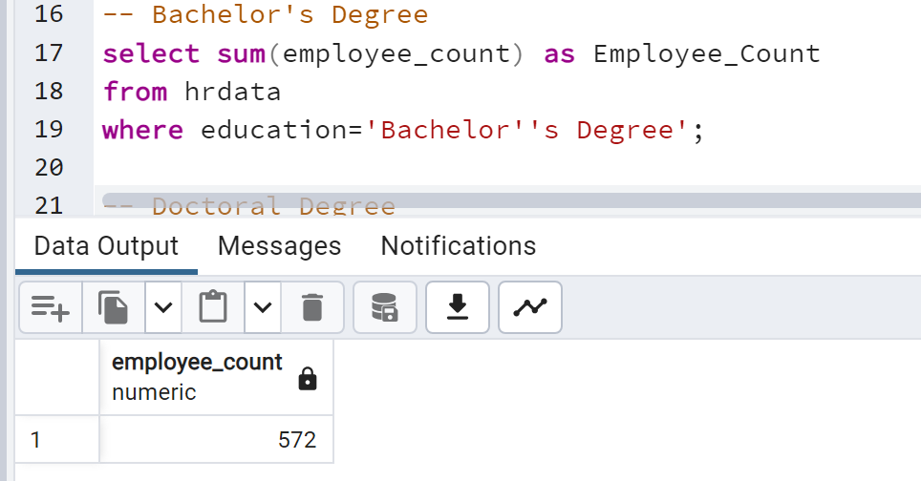

* DOCTORAL DEGREE

**select sum(employee_count) as Employee_Count from hrdata where education='Doctoral Degree';**

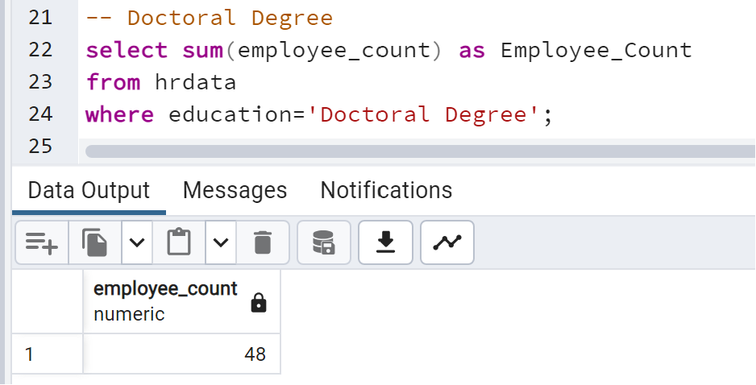

* HIGH SCOOL DEGREE

**select sum(employee_count) as Employee_Count from hrdata where education='High School';**

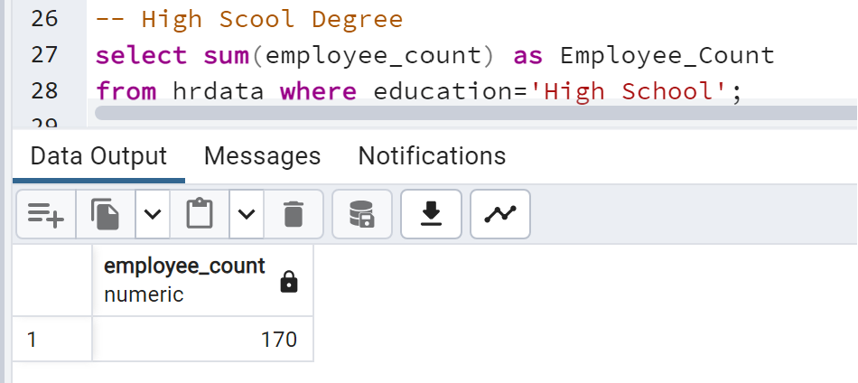

* MASTER'S DEGREE

**select sum(employee_count) as Employee_Count from hrdata where education='Master''s Degree';**

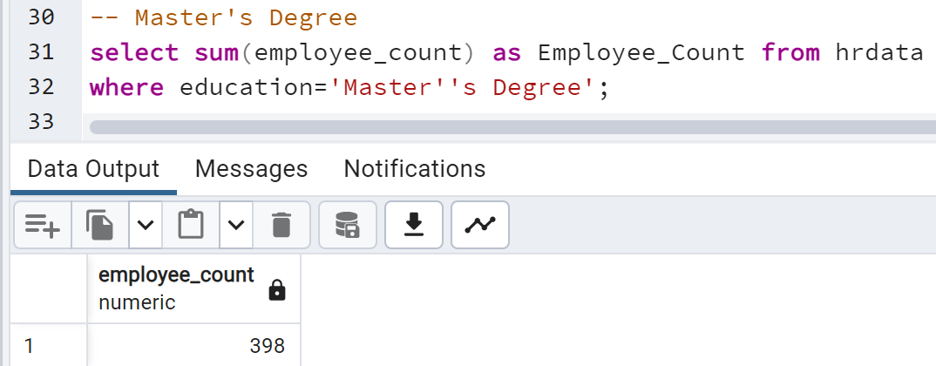

1. TOTAL ATTRITION COUNT

**select count(attrition) from hrdata**

**where attrition='Yes';**

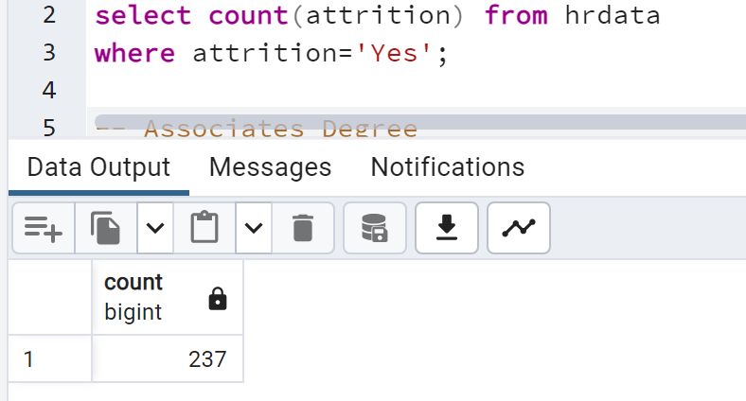

* ASSOCIATES DEGREE

**select count(attrition) from hrdata where attrition='Yes' and education='Associates Degree';**

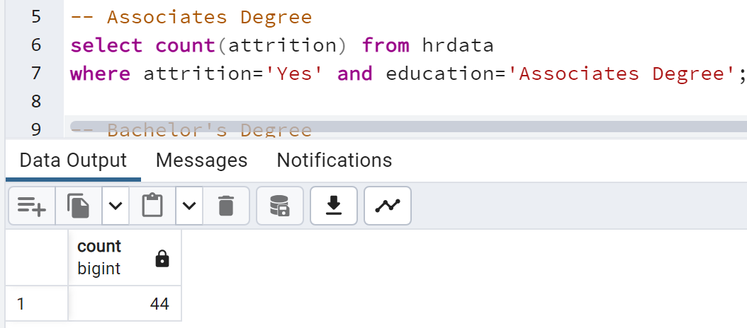

* BACHELOR'S DEGREE

**select count(attrition) from hrdata where attrition='Yes' and education='Bachelor''s Degree';**

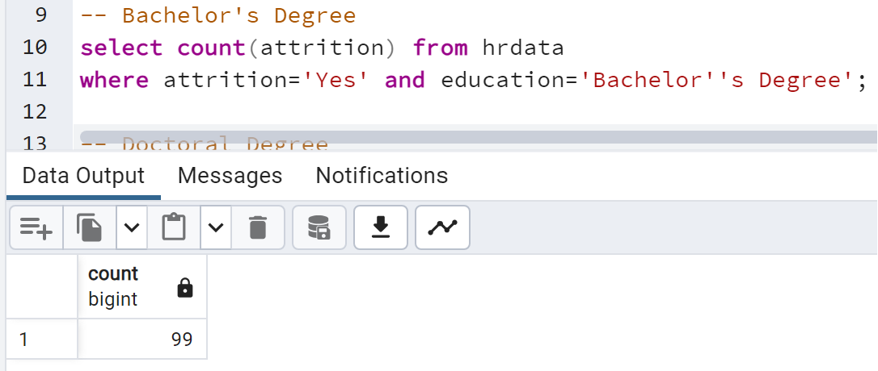

* DOCTORAL DEGREE

**select count(attrition) from hrdata where attrition='Yes' and education='Doctoral Degree';**

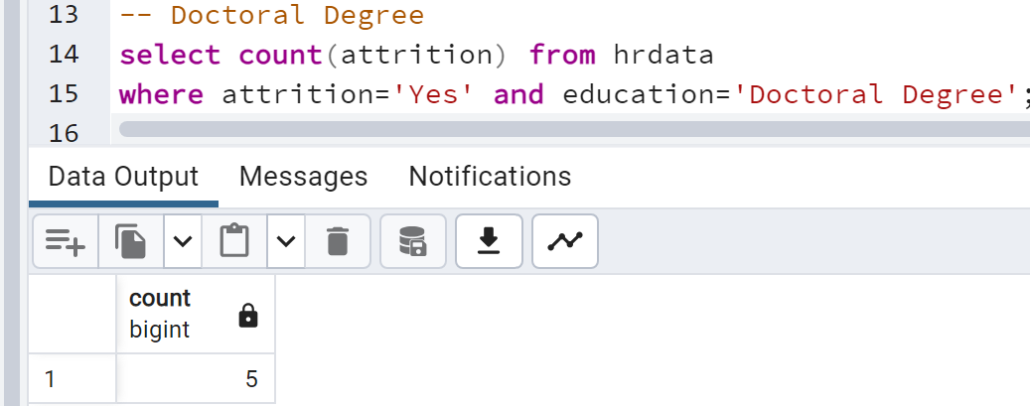

* HIGH SCOOL DEGREE

**select count(attrition) from hrdata where attrition='Yes' and education='High School';**

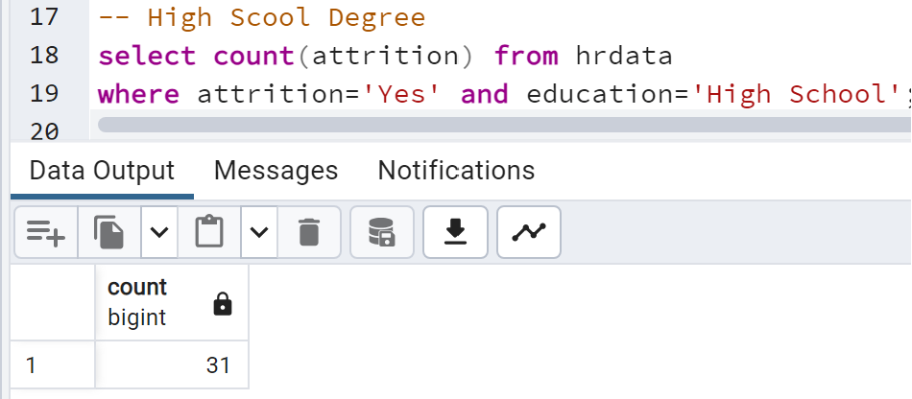

* MASTER'S DEGREE

**select count(attrition) from hrdata where attrition='Yes' and education='Master''s Degree';**

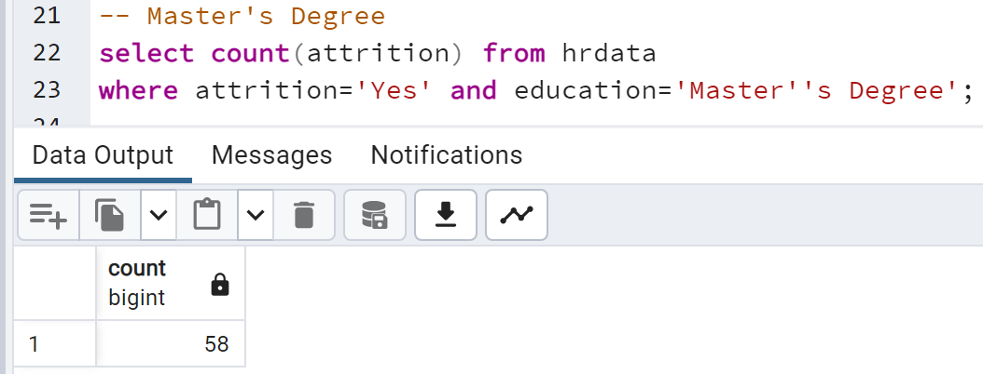

1. ATTRITION RATE

**select round((select count(attrition) from hrdata**

**where attrition='Yes')/**

**sum(employee_count)*100,2) from hrdata;**

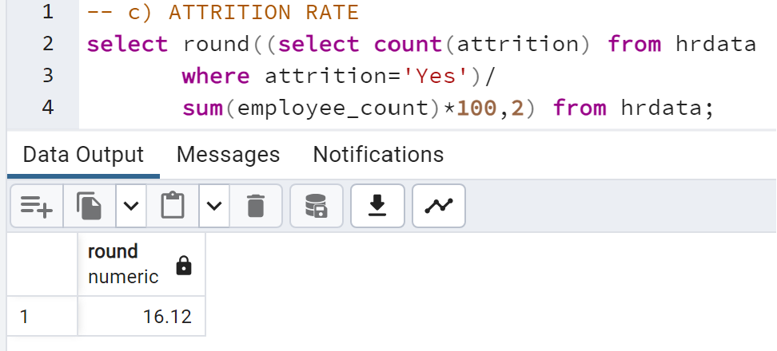

* ASSOCIATE DEGREE

**select round((select count(attrition) from hrdata**

**where attrition='Yes' and education='Associates Degree')/**

**(select sum(employee_count) from hrdata**

**where education='Associates Degree')*100,2);**

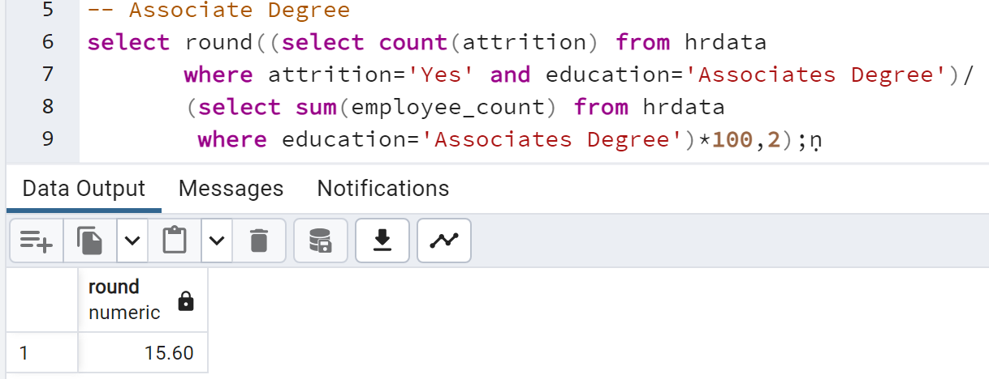

* BACHELOR'S DEGREE

**select round((select count(attrition) from hrdata**

**where attrition='Yes' and education='Bachelor''s Degree')/**

**(select sum(employee_count) from hrdata**

**where education='Bachelor''s Degree')*100,2);**

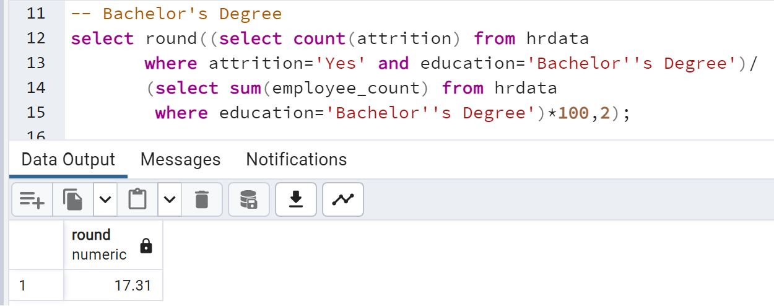

* DOCTORAL DEGREE

**select round((select count(attrition) from hrdata**

**where attrition='Yes' and education='Doctoral Degree')/**

**(select sum(employee_count) from hrdata**

**where education='Doctoral Degree')*100,2);**

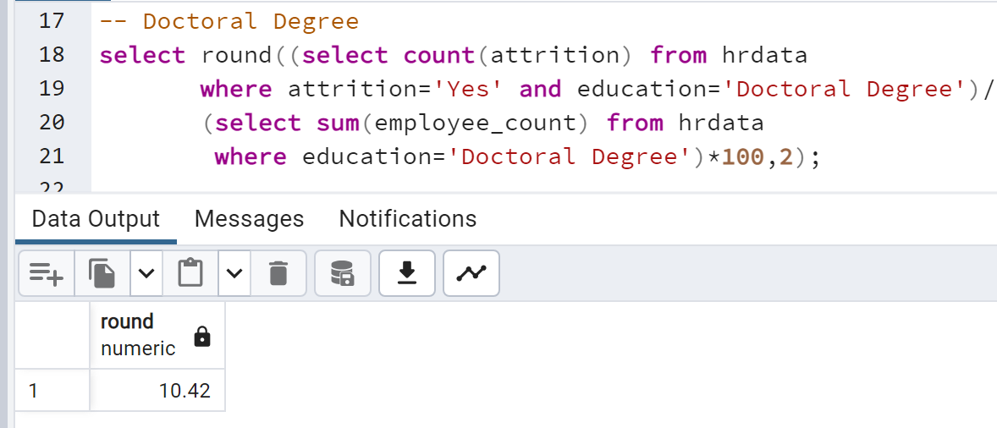

* HIGH SCOOL DEGREE

**select round((select count(attrition) from hrdata**

**where attrition='Yes' and education='High School')/**

**(select sum(employee_count) from hrdata**

**where education='High School')*100,2);**

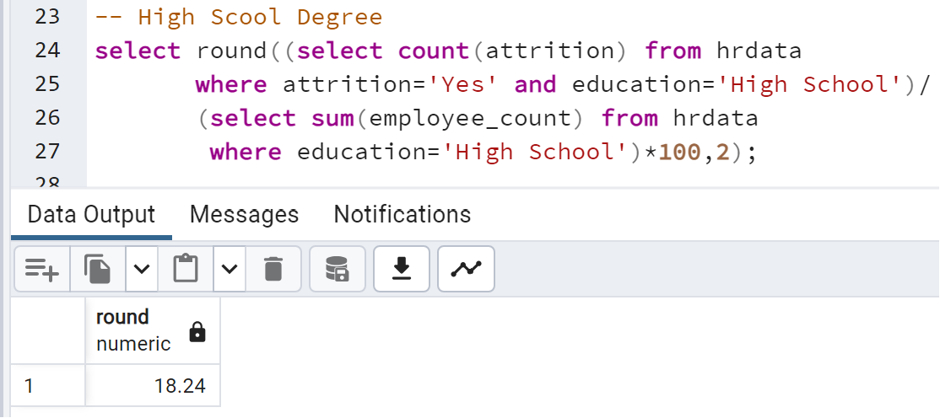

* MASTER'S DEGREE

**select round((select count(attrition) from hrdata**

**where attrition='Yes' and education='Master''s Degree')/**

**(select sum(employee_count) from hrdata**

**where education='Master''s Degree')*100,2);**

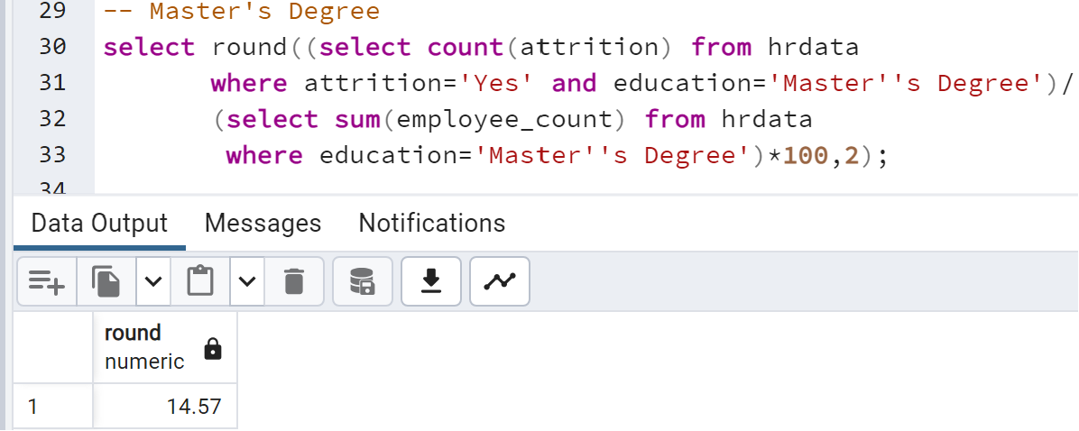

1. ACTIVE EMPLOYEES

**SELECT COUNT(attrition) AS "Active Employees"**

**FROM hrdata WHERE attrition = 'No';**

-- OR

**select sum(employee_count) - (select count(attrition)**

**from hrdata where attrition='Yes') from hrdata;**

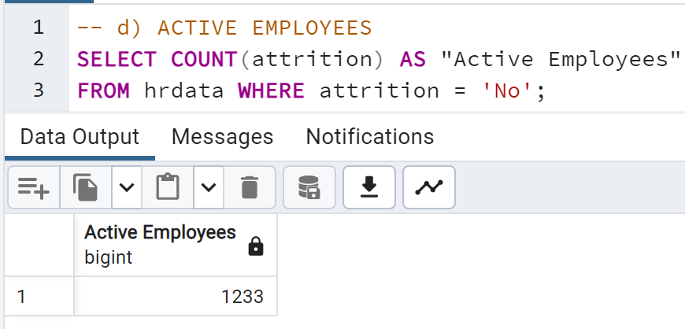

* + ASSOCIATES DEGREE

**SELECT COUNT(attrition) AS "Active Employees"**

**FROM hrdata WHERE attrition = 'No'**

**AND Education='Associates Degree';**

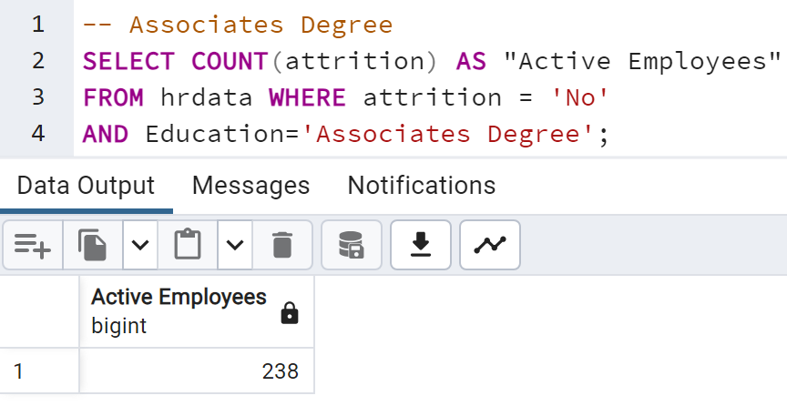

* BACHELOR'S DEGREE

**SELECT COUNT(attrition) AS "Active Employees"**

**FROM hrdata WHERE attrition = 'No'**

**AND Education='Bachelor''s Degree';**

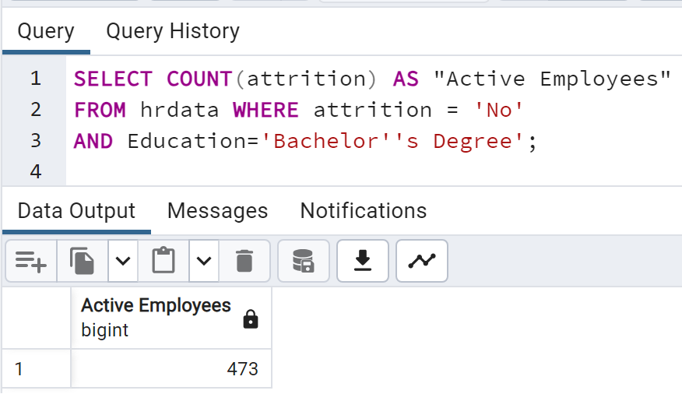

* DOCTORAL DEGREE

**SELECT COUNT(attrition) AS "Active Employees"**

**FROM hrdata WHERE attrition = 'No'**

**AND Education='Doctoral Degree';**

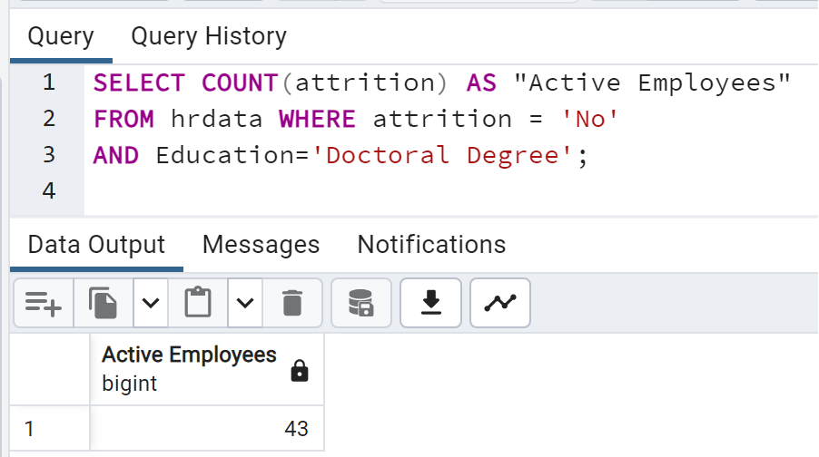

* HIGH SCOOL DEGREE

**SELECT COUNT(attrition) AS "Active Employees"**

**FROM hrdata WHERE attrition = 'No'**

**AND Education='High School';**

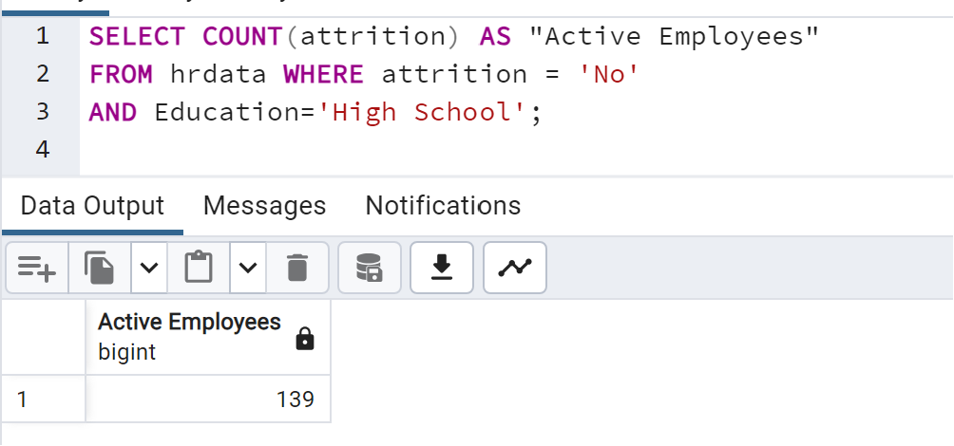

* MASTER'S DEGREE

**SELECT COUNT(attrition) AS "Active Employees"**

**FROM hrdata WHERE attrition = 'No'**

**AND Education='Master''s Degree';**

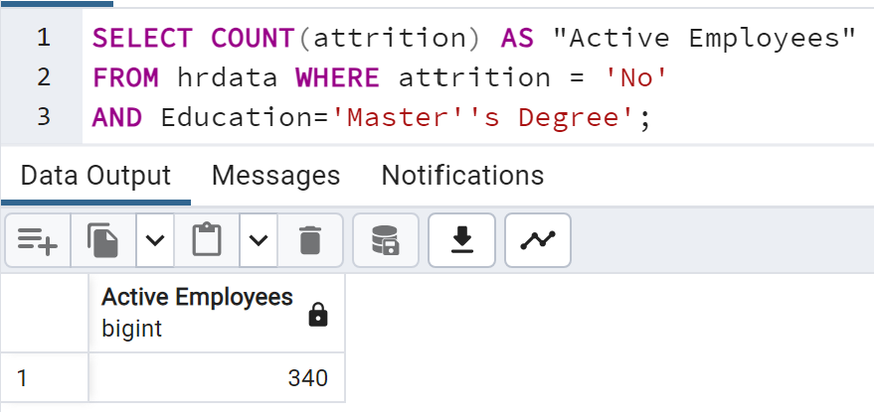

1. AVERAGE AGE

**SELECT round(AVG(AGE)) AS "Average Age"**

**FROM hrdata;**

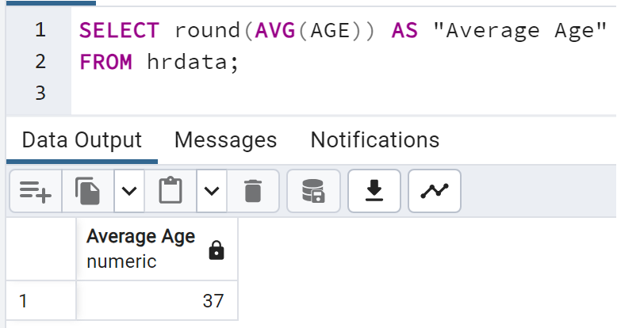

* + ASSOCIATES DEGREE

**SELECT round(AVG(AGE)) AS "Average Age"**

**FROM hrdata where Education='Associates Degree';**

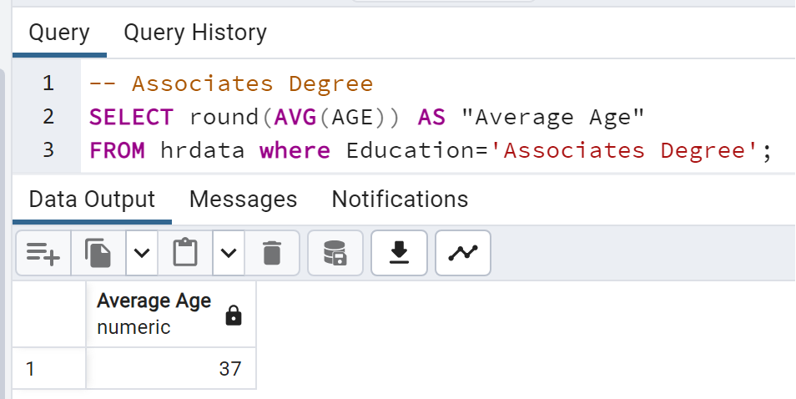

* + BACHELOR'S DEGREE

**SELECT round(AVG(AGE)) AS "Average Age"**

**FROM hrdata where Education='Bachelor''s Degree';**

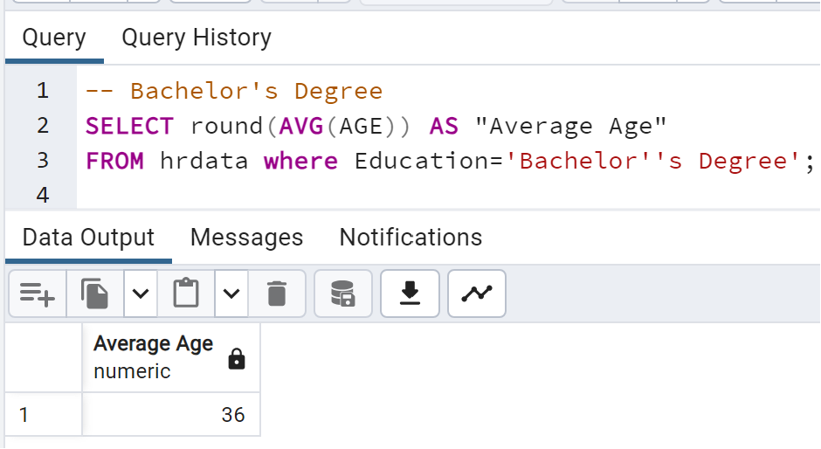

* + DOCTORAL DEGREE

**SELECT round(AVG(AGE)) AS "Average Age"**

**FROM hrdata where Education='Doctoral Degree';**

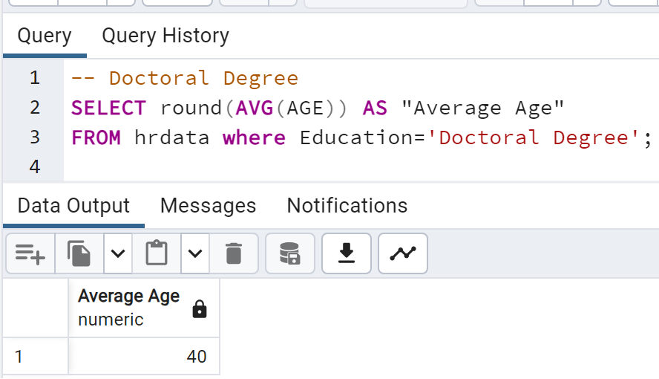

* + HIGH SCOOL DEGREE

**SELECT round(AVG(AGE)) AS "Average Age"**

**FROM hrdata where Education='High School';**

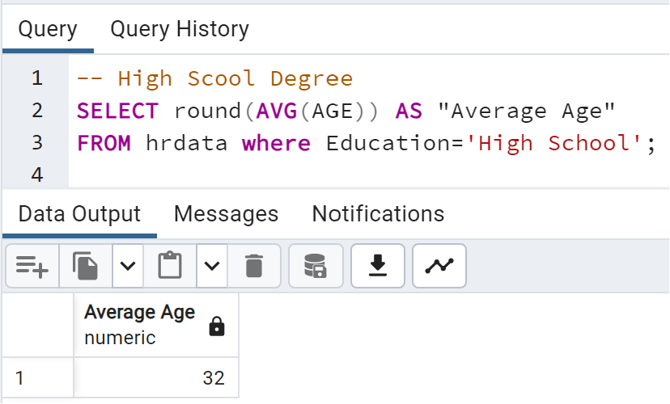

* + MASTER'S DEGREE

**SELECT round(AVG(AGE)) AS "Average Age"**

**FROM hrdata where Education='Master''s Degree';**

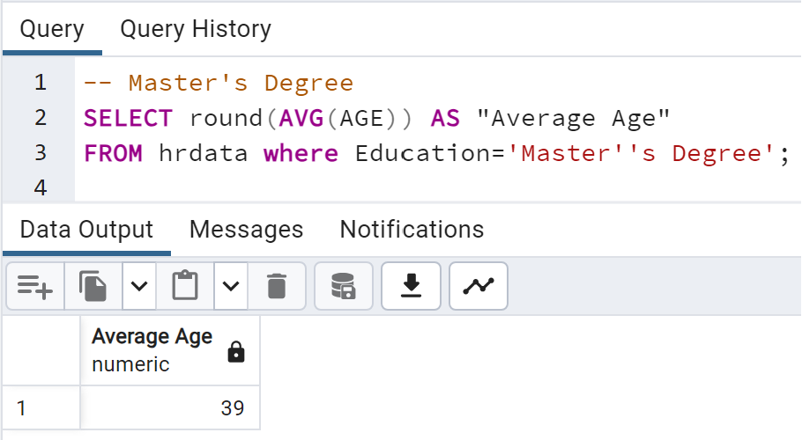

1. ATTRITION BY GENDER

**SELECT gender, COUNT(attrition) AS attrition_count**

**FROM hrdata**

**WHERE attrition='Yes'**

**GROUP BY gender**

**ORDER BY COUNT(attrition) DESC;**

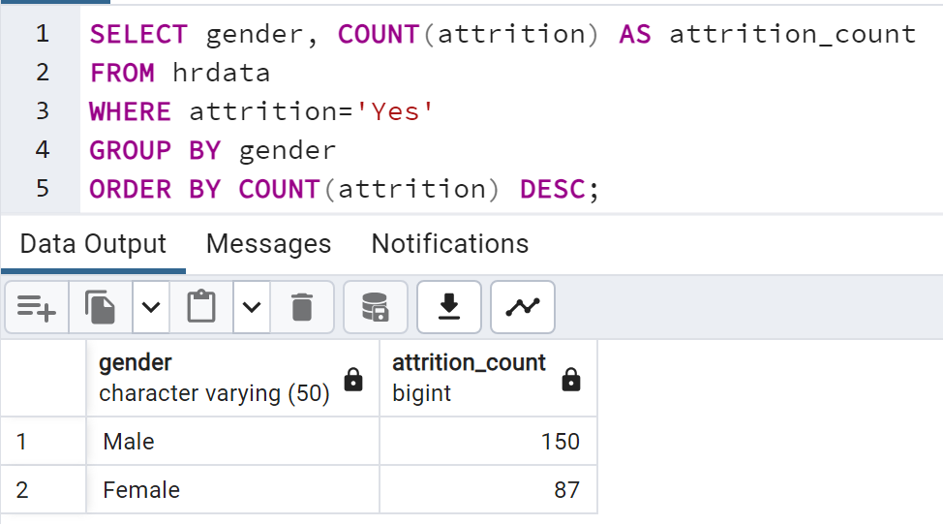

1. DEPARTMENT WISE ATTRITION:

**SELECT department, COUNT(attrition), round((CAST (COUNT(attrition) AS numeric) /**

**(SELECT COUNT(attrition) FROM hrdata WHERE attrition= 'Yes')) * 100, 2) AS percent**

**FROM hrdata**

**WHERE attrition='Yes'**

**GROUP BY department**

**ORDER BY COUNT(attrition) DESC;**

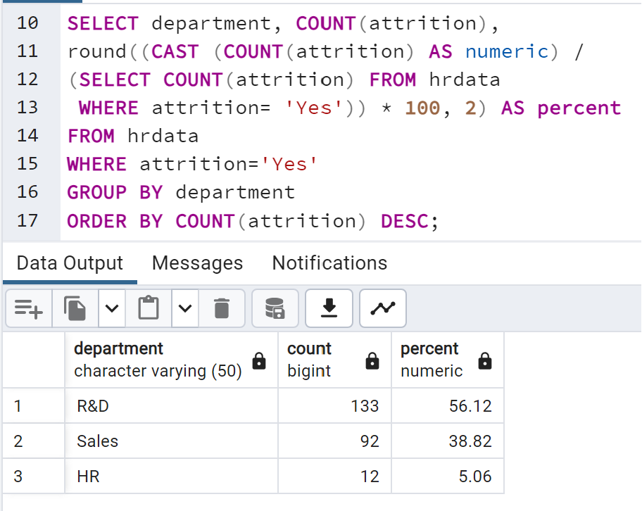

1. NO OF EMPLOYEE BY AGE GROUP

**SELECT age_band, gender, SUM(employee_count)**

**AS count_of_employees**

**FROM hrdata**

**GROUP BY age_band, gender**

**ORDER BY age_band, gender DESC;**

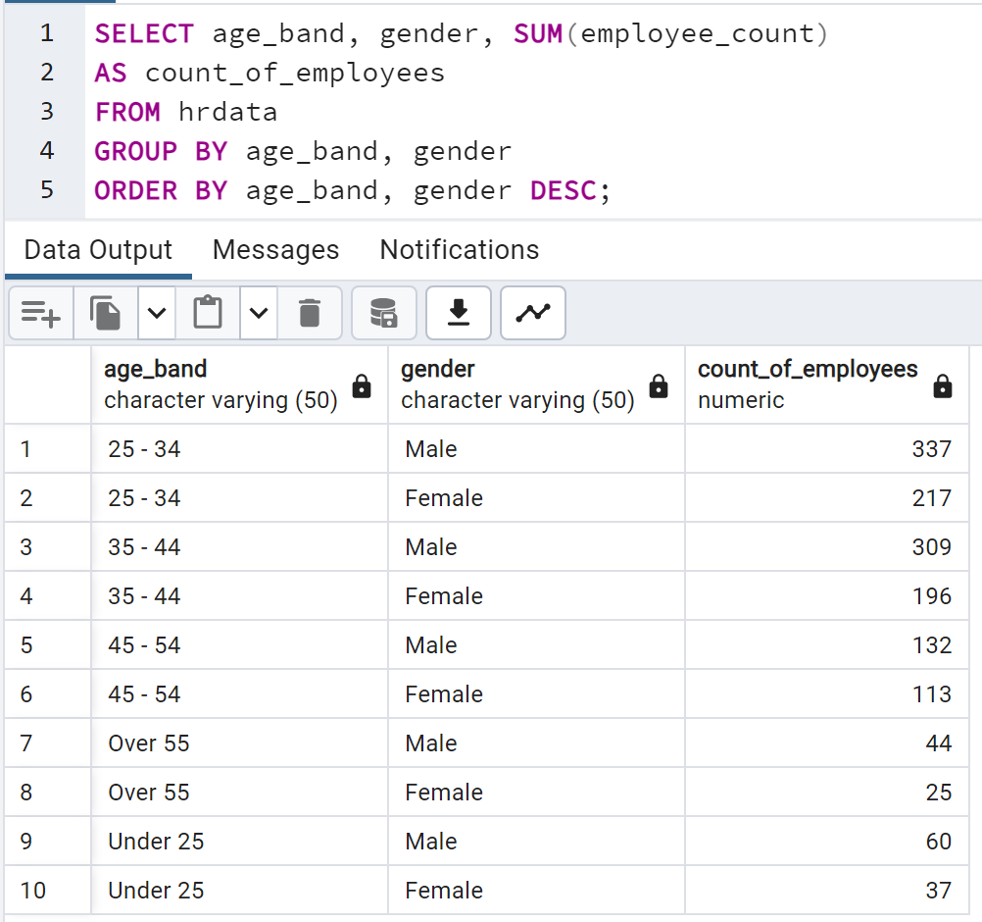

1. EDUCATION FIELD WISE ATTRITION:
2. ATTRITION RATE BY GENDER FOR DIFFERENT AGE GROUP
3. JOB SATISFACTION RATING